1. INTRODUCTION
   1. Team name, group members, partnering organization

Upsilon Gamma Beta

Bailey Davin, Tori Reiner, Ellie Niesz, Gabe Wilson, Daniel Xu, Joey Lanzona, Charlotte Brief-Piltz

Wilmington Green Box

* 1. Briefly explain your project

Creating community garden to give teenagers entrepreneurship opportunities and access to healthy food, healthy and self-sustaining

* 1. True color, strengths, and shadow of each team member

Gold, Orange, Green, Blue

Hero, Mentor, Go-Getter, Merrymaker, Friend, Peacemaker, Guardian, Expert, Monarch

Tyrant, Critic, Sadist, Worrier, Know-It-All, Avoider, Side-kick, people-pleaser, rush hound

* 1. Which unique abilities does each member bring to the group that makes them a desirable group member and partner?

Gabe - flexibility, adaptability, resourceful,

Daniel - knows how to plant a tree correctly, neat

Bailey - communication skills, follow-through, advocator, committed

Tori - organization, motivation, knowledge in sustainable engineering, plant science

Ellie - motivation, keeping people on task, time management, likes to work with hands!

Joey - social media, vegan

Charlotte - active listening, reaffirming

1. CONTEXT
   1. What organizational problem is your team addressing?

Addressing food vendors, finding a way to skip the middleman, remaining local, 20x40 big garden!, a place for kids to learn hard skills on the farm, more funding (walk → pull more funding for the organization), resources

* 1. What result is expected?

Urban farm, funding, local produce, entrepreneurship opportunities for kids

* 1. Why is this important for the mission or impact of the organization?

Values: at risk teen employment

Employment opportunities for the farm

Healthy and sustainable eating

Nutrition education

1. TEAM ROLES

Bailey - Main Pivot for Communication

Ellie - Agenda Keeper

Charlotte - Facilitator

Tori - Research

Dan - Graphics Director

Joey - Scribe

Gabe - Accountability

Since we have a big group, we plan on being flexible with our roles and to fill them whenever possible.

1. RESOURCES AND SUPPORT AVAILABLE

Megan Chen from TUGI

Jason

Delaware Center of Horticulture

Home Depot

1. MISSION AND OBJECTIVES

Using our values towards environmental sustainability, uplifting community, and improving accessibility, we strive to implement an urban garden for a space for community gathering and self-improvement.

We have a document of our monthly goals:

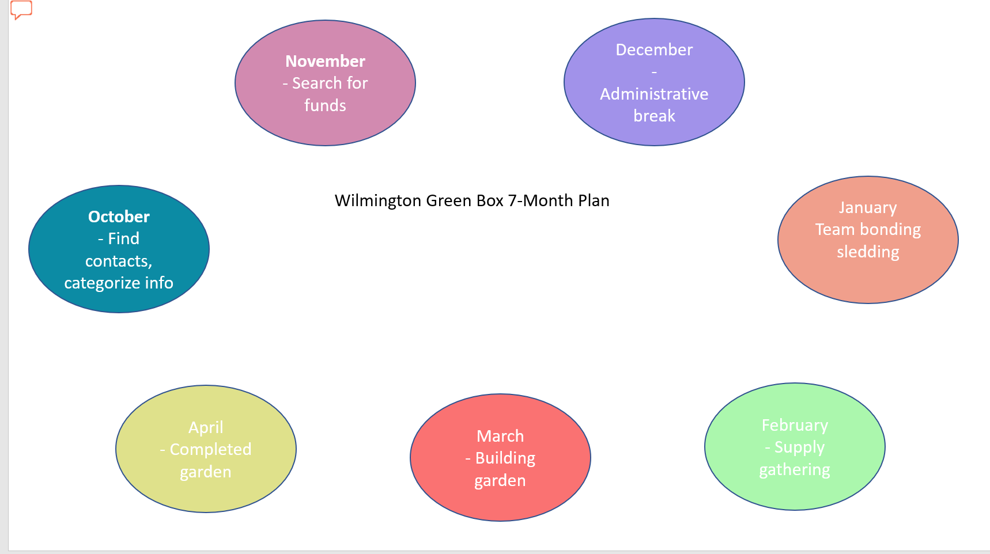

1. UNIQUE VALUE PROPOSITION

We are renovating a public garden to our vision of sustainability to complement the community-driven approach it had.

Our superpower is our flexibility and creativity because this project has welcomed us with the opportunity to do whatever we would like to do.

1. APPROVAL